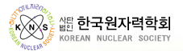

Korean Nuclear Society
2017 US Chapter Annual Meeting

ANS Annual Meeting
Hyatt Regency, San Francisco, CA
4:30 – 6:30 pm, Monday, June 12, 2017
Location: Board Room C

Time | Item
04:30 PM | Registration
04:40 PM | Opening
04:45 PM | Action items from the 2016 Winter Meeting
05:10 PM | Discussion on new chapter business
05:20 PM | Special presentation :  “DOE Nuclear Liquid Waste Processing”  by Dr. Si Young Lee, SRNL

