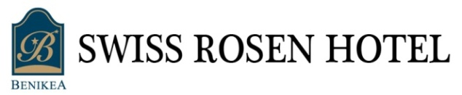
Reservation Form
한국원자력학회 2016추계학술발표회
(2016. 10. 26 ~ 10. 28)

* Please complete this form with all requested information and send it to the hotel directly by e-mail or fax.
아래의 예약요청서 양식을 작성하여 이메일이나 팩스로 보내주시기 바랍니다.
E-mail : swissrosen@gmail.com Fax : +82-54-748-1998 (Tel +82-54-748-4848).
PERSONAL INFORMATION
NAME 성명 |  |  |  |  | NUMBER OF GUEST 숙박인수
PHONE |  |  |  |  | E-MAIL
 | CHECK-IN |  |  |  |  | CHECK-OUT
 | NUMBER OF ROOMS 객실수 |  |  |  |  | NUMBER OF NIGHTS 숙박일수
 | ROOM TYPE & RATE
 | ROOM TYPE |  | 10/25~10/27 | 10/28 |  |  | • Breakfast ( 07:30 ~ 09:00)  : KRW 10,000 / 1 person  □ YES (PAX 인원수 : )  □ NO
 | DOUBLE |  | □ KRW 82,000 | □ KRW 94,000
 | TWIN |  | □ KRW 87,000 | □ KRW 99,000
 | ONDOL |  | □ KRW 82,000 | □ KRW 94,000
• Above rates are inclusive of 10% VAT. 10% 부가세 포함 금액임

PAYMENT 결제정보
CARD TYPE | □ VISA □ MasterCard □ BC □ American Express □ Others
CARD NUMBER
CARD HOLDER NAME |  | EXPIRY DATE 유효기간 | (MM/YY)
- Cancellation Policy
Cancellation made before 5~7 days prior to arrival : 10% of the total paying.
Cancellation made before 3~5 days prior to arrival : 30% of the total paying.
Cancellation made before 1~2 days prior to arrival : 50% of the total paying.
Cancellation made on arrival day or No Show : 100% of the total paying.

