Nuclear Power in Korea
17 September 2025
KiBog LEE, kblwhl@hanmail.net, +82-010-5389-8753

1. Why Nuclear Power Matters in Korea
Now, I would like to share with you the current status and future outlook of nuclear power in Korea. For Korea, nuclear power is more than just a technology. It is a carbon-free energy source that helps us meet our climate goals, a stable economical supplier of electricity to support our rapidly growing huge demand, and a quasi-domestic energy resource that strengthens national energy security by reducing dependence on imported fossil fuels. Korea lacks natural resources including renewable resources, so Korea imports 95% of energy resources that corresponds to 25% national import.

2. Current Status of Nuclear Power in Korea
Korea began its nuclear era in 1978 with the commercial operation of Kori Unit 1. Since then, nuclear power has steadily expanded.
Operating Reactors: In 2025, currently 26 nuclear power units are in operation today, with a total installed capacity of about 26 GWe, supplying roughly 30–32%of the nation’s electricity.
Permanently Shut Down Reactors: Kori Unit 1 (2017) and Wolsong Unit 1 (2019) have been permanently shut down and are under decommissioning.
New Construction: Construction of Shin-Hanul Units 3 & 4 has resumed, with commercial operation targeted for the early 2030s.

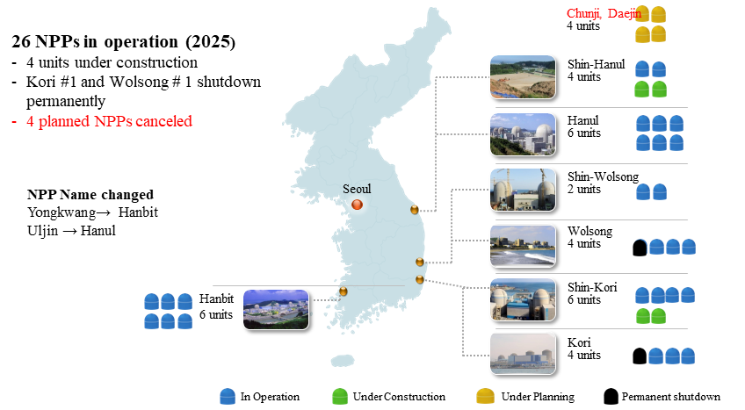
Nuclear Power Plants in Korea

Continued Operation: Units reaching the end of their design life are applying for life extension after passing rigorous safety reviews.
Nuclear power remains cost-competitive, with an average generation cost of around 60 KRW/kWh, cheaper than coal and LNG, while providing stable, reliable power.

3. The 11th Basic Plan for Long-term Electricity Supply and Demand
In 2025, the government finalized the 11th Basic Plan for Long-term Electricity Supply and Demand (2024–2038).
The plan includes:
Construction of two new large nuclear power units
Construction of one Small Modular Reactor (SMR)for demonstration
Expanding renewable energy to account for over 30% of generation by 2038
Strengthening system flexibility through ESS, pumped storage, and LNG backup capacity
This plan reflects a balanced power mix strategy, maintaining nuclear power as a carbon-free baseload source while significantly expanding renewables.
Now, Preparations are underway to establish the 12th Basic Plan for Long-term Electricity Supply and Demand, which will be applied from 2026 to 2040.

4. Nuclear Technology Development and SMR Programs
Korea has obtained Standard Design Approval (SDA)for the SMART and SMART100 Small Modular Reactors (SMRs), laying the groundwork for domestic demonstration and overseas deployment.
The i-SMR Development Programaims to complete SDA by 2028 and install the first module by 2031. In parallel, the SMR Regulatory Research Task Forceis proactively preparing regulatory frameworks, including multi-module safety requirements and licensing guidelines.

5. Nuclear Export Achievements
Korea’s nuclear technology has gained international recognition.
UAE Barakah Project: Successfully delivered four APR-1400 units on time and within budget, earning global trust.
Czech Dukovany Project: In 2025, Korea signed the final contract to build Dukovany Units 5 & 6, marking a major entry into the European market.
University of Missouri Research Reactor: Won the contract for next-generation research reactor design, demonstrating Korea’s engineering and design capabilities.
These achievements confirm Korea’s status as a global nuclear power exporter.

6. Legal and Institutional Developments
High-level Radioactive Waste Management Act (2025) : Established legal procedures for site selection, interim storage, and final disposal
Provided frameworks for community compensation and public participation
Distributed Energy Promotion Act (2023): Introduced compensation for the grid benefits of small-scale solar, wind, ESS, and demand response
SMR Special Support Act (proposed)
Currently under review in the National Assembly
Aims to support demonstration projects, provide tax and financial incentives, and accelerate commercialization

7. Government Reorganization and Policy Direction
In 2025, the Korean government implemented a major administrative reorganization:

Ministry of Trade, Industry and Energy (MOTIE): Responsible for nuclear export promotion
Ministry of Science and ICT (MSIT): Oversees nuclear R&D
New Ministry of Climate, Energy and Environment(to be launched on October 1): Responsible for nuclear construction, operation, and safety
The Nuclear Safety and Security Commission (NSSC): an independent central government agency responsible for the licensing, safety regulation, radiation protection, and emergency response of nuclear facilities and radiation-utilizing installations.
President Lee Jae-myung’s administration emphasizes rapid expansion of renewable energysuch as solar, wind, and energy storage systems (ESS).
This approach may slow the pace of new nuclear construction in the short term but places greater emphasis on safe operation, life extension of existing units, and SMR demonstration projects.

8. Outlook for Korean Nuclear Power
Looking ahead, the future of Korean nuclear power can be viewed in three phases:
Short Term (1–5 years):
Focus on expanding renewable and distributed generation, strengthening grid stability, and ensuring safe operation and life extension of existing nuclear plants.
Medium Term (5–10 years):
Completion of i-SMR design approval and the first demonstration module, paving the way for deployment as regional and industrial power sources.
Long Term (10–15 years):
Construction and operation of two new large reactors as planned, establishing a hybrid energy mix of nuclear and renewables to meet carbon neutrality goals and ensure energy security.

9. Conclusion
Korea possesses world-class capabilities in nuclear design, construction, and operation.
Through successful exports such as the UAE Barakah project, recent Checko Dokobani project and ambitious SMR development programs, Korea is poised to remain a nuclear technology leader.
However, challenges remain: safe and publicly accepted management of high-level radioactive waste, social consensus on new plant siting, harmonizing renewables and nuclear in the grid, and proving the cost competitiveness of SMRs.
Moving forward, Korea’s energy strategy must ensure a balanced mix of nuclear and renewables, while communicating transparently with the public and building international trust.
Only then can we simultaneously achieve climate goals, energy security, and economic stabilityfor the nation’s future.

