Hotel International Reservation
2022 한국원자력학회
학회

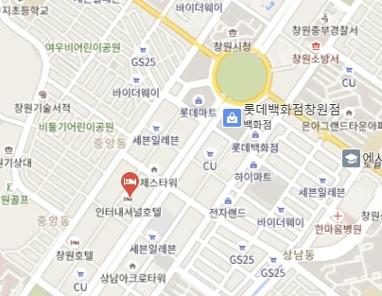
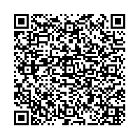
2022. 10. 18 ~ 2022. 10. 21
Please send it by email : inter@hi1001.co.kr
Booking Detail
- Name
- Phone
- Check In
- Check Out
- No. of Rooms
- Room Type | BUSINESS DOUBLE /  SUPERIOR DOUBLE /  BUSINESS TWIN
- Breakfast | Yes / No
- Payment : Creditcard Number |  | Valid (MM/YY: / )

Convenience Facilities
- FREE Gym / 50% discount Sauna | - Business Center
- FREE Wi-Fi Internet | - Music Live Bar
- FREE Parking Area | - Coffee shop
- 24hr Front Desk

Cancelation Policy is subject to exceptions
- 5 days before check-in: no penalty
- 3 days before check-in : 30% of the fee charged
- 2 days before check-in : 50% of the fee charged
- on the day of check-in: 100% of the fee charged

Please contact us at any time if you have any inquires.
We look forward to welcoming Hotel International.
Sincerely Yours,
KANG RINA / Assistant-Manager

